Colonial Adventure Tours

1. SELECT LAST_NAME

FROM GUIDE

WHERE STATE <> ‘MA’;

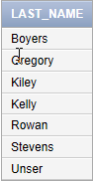

1. SELECT *

FROM TRIP

WHERE TYPE = ‘Biking’;

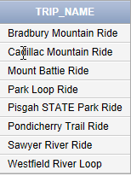

1. SELECT TRIP_NAME

FROM TRIP

WHERE SEASON = ‘Summer’;

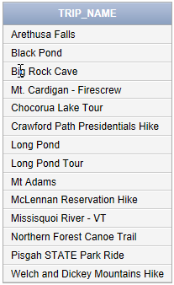

1. SELECT TRIP_NAME

FROM TRIP

WHERE TYPE = ‘Hiking’ AND DISTANCE > 10;



1. SELECT CUSTOMER_NUM, LAST_NAME, FIRST_NAME

FROM CUSTOMER

WHERE STATE IN (‘NJ’, ‘NY’, ‘PA’);

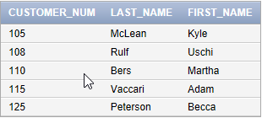

1. SELECT CUSTOMER_NUM, LAST_NAME, FIRST_NAME

FROM CUSTOMER

WHERE STATE IN (‘NJ’, ‘NY’, ‘PA’)

ORDER BY STATE DESC, LAST_NAME;

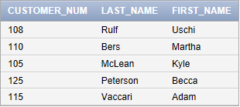

1. SELECT COUNT(STATE) AS TOTAL_TRIPS_IN_MA_OR_ME

FROM TRIP

WHERE STATE IN (‘ME’, ‘MA’);



1. SELECT STATE, COUNT(STATE)

FROM TRIP

GROUP BY STATE;

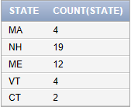

1. SELECT COUNT(TRIP_PRICE)

FROM RESERVATION  
WHERE TRIP_PRICE > 20 AND TRIP_PRICE < 75;



1. SELECT TYPE, COUNT(TYPE)

FROM TRIP

GROUP BY TYPE;

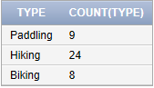

1. SELECT RESERVATION_ID, TRIP_ID, CUSTOMER_NUM, (TRIP PRICE + OTHER_FEES) * NUM_PERSONS AS TOTAL_PRICE

FROM RESERVATION

WHERE NUM_PERSONS > 4;

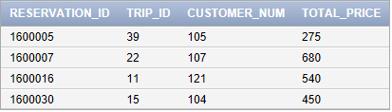

1. SELECT TRIP_NAME

FROM TRIP  
WHERE TRIP_NAME LIKE ‘%Pond%’;

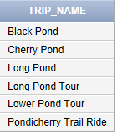

1. SELECT LAST_NAME, FIRST_NAME

FROM GUIDE

WHERE HIRE_DATE < ‘6/10/2013’;

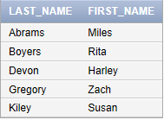

1. SELECT TYPE, AVG(DISTANCE), AVG(MAX_GRP_SIZE)

FROM TRIP

GROUP BY TYPE;

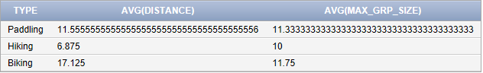

1. SELECT DISTNCT(SEASON)

FROM TRIP;

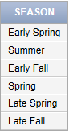

1. SELECT RESERVATION_ID

FROM RESERVATION

WHERE TRIP_ID IN

(SELECT TRIP_ID

FROM TRIP  
WHERE TYPE = ‘Paddling’);

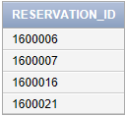

1. SELECT MAX(DISTANCE) AS LONGEST_DISTANCE

FROM TRIP

WHERE TYPE = ‘Biking’;



1. SELECT TRIP_ID, SUM(TRIP_PRICE)

FROM RESERVATION

HAVING COUNT(TRIP_ID) > 1

GROUP BY TRIP_ID

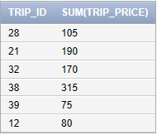

1. SELECT COUNT(RESERVATION_ID) AS RESERVATIONS, SUM(NUM_PERSONS) AS TOTAL_PEOPLE

FROM RESERVATION



1. SELECT RESERVATION_ID, TRIP_ID

FROM RESERVATION

WHERE TRIP_DATE BETWEEN ‘7/01/2016’ AND ‘7/31/2016’;

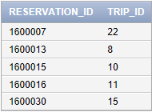

Alternate Command:

SELECT RESERVATION_ID, TRIP_ID

FROM RESERVATION

WHERE TRIP_DATE > ‘7/01/2016’ AND TRIP_DATE < ‘7/31/2016’